

**Technical report**

**From Kickoff to Glory: Football Match Analysis Through History Dashboard**

**Firstly, the data is about the statistics of football since its creation and all this information is transformed into meaningful insights that are simple and easy to understand, which we will explore throughout our journey.**

**Secondly, we obtained the dataset and cleaned it using various tools such as Python. This process ensured the data was more understandable and easier to visualize.**

**Lastly, we have some questions that should be answered to understand the main purpose of this dataset which provides general information about the historical events that happened, the most successful and unsuccessful national team and the most successful national players.**

**These are The Questions and their answers that we get from the Dashboard.**

1. **How many official, qualification and unofficial matches got played?**

**Official matches were: 4665 matches**

**Qualifications matches where: 14.35K**

**Friendly matches where: 28.39K**

**Total matches: 47.40K**

1. **What is the total number of cities?**

**2065**

1. **What is the total number of countries?**

**273**

1. **What are the total number of tournaments?**

**175**

1. **How many goals were scored?**

**Friendly are equal to 86K**

**Qualifications are equal to 41K**

**Officials are equal to 13K**

**Total is 139K**

1. **Teams with the most wins**

1. **The teams with the most official wins**

1. **Teams with the most friendly wins**

1. **teams with the most qualifications wins**

1. **teams with the most losses**

1. **teams with the most friendly losses**

1. **teams with the most qualifications losses**

1. **teams with the most official losses**

1. **What is the total number of draws?**

**Total draws: 10,780 Match**

1. **Players with most overall goals**

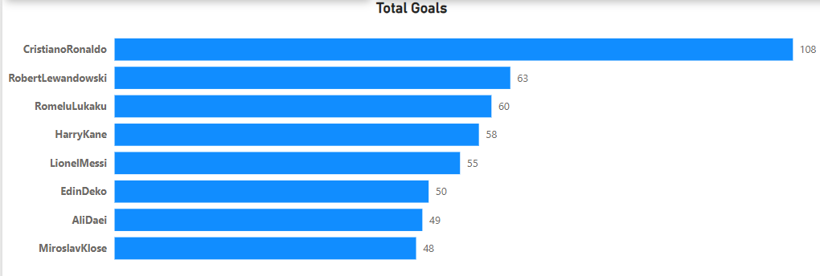

1. **Players with most goals in the first stage**

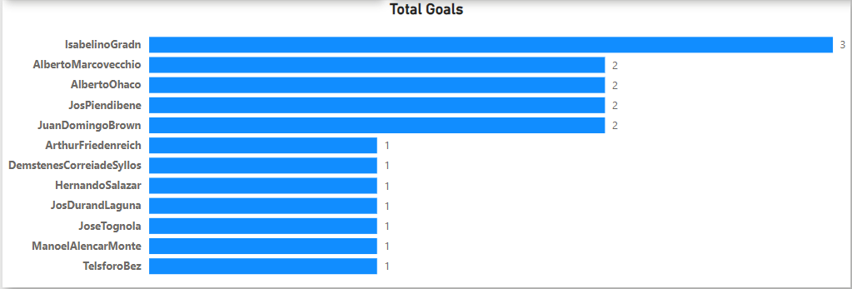

1. **Players with most goals in the second stage**

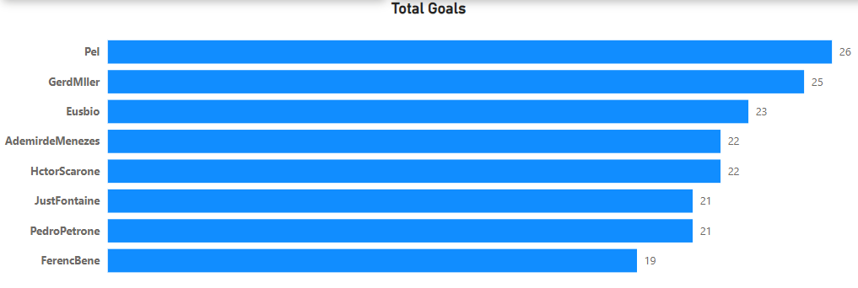

1. **Players with most goals in the third stage**

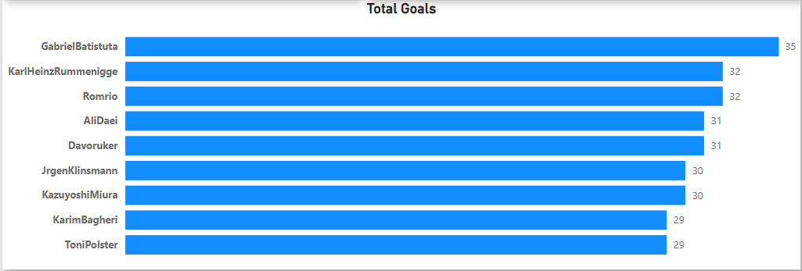

1. **Players with most goals in the last stage**

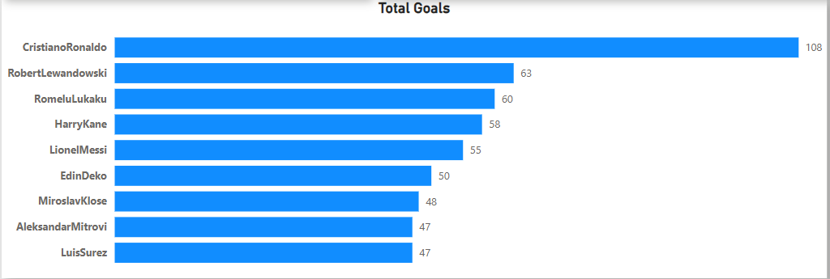

1. **Players with most overall scored penalty goals**

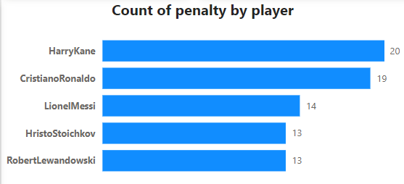

1. **When is the time during match all goals scored?**

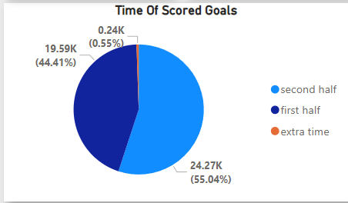

**Inconclusion, we were able to collect and visualize data about football since its creation those information includes the most wins, losses and draws in each part whether it was for qualification or friendly or official matches. Moreover, we visualized the players who scored the most goals throughout football’s history.**